# **SAFE OPERATING GUIDELINES**

# **Line Trimmer “Whipper Snipper” - Fuel Operated**

**DO NOT use this machine unless you have received instruction**

**in its safe use, operation and maintenance**

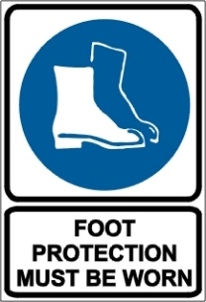 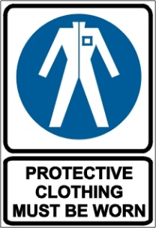 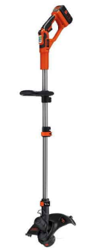



**HAND**

**PROTECTION**

**POTENTIAL HAZARDS & RISKS include**

High speed cutting wire, Noise, Ejected material and flying debris, manual handling, Eye /face or body injuries, Traffic, vibration, burns, fire, slip/trip/fall, fumes, entanglement

**Note: The deflector on this power tool cannot protect the operator from all objects thrown by the cutting attachment (stones, glass, wire, etc.) Such objects may ricochet and then hit the operator**

### **PRE-OPERATIONAL SAFETY CHECKS**

* Secure in vehicles to prevent fuel spillage and damage (if applicable)
* Ensure all safety devices - deflector, switches, attachments are fitted, secure and functional as per manufacturer’s guide /instruction manual; handles dry and clean – free from oil and dirt, absence fuel leaks
* Ensure slide control / stop switch moves easily to STOP or 0 and the throttle trigger returns automatically to the idle position
* Adjust handles or straps for your height to keep unit positioned below waist height
* Faulty equipment must not be used; Report faulty machinery immediately and **TAG OUT OF SERVICE**
* Know where Fire Fighting Equipment and First aid kit is located

#### OPERATIONAL SAFETY CHECKS

* Check own physical and mental health – applies to all power tool use (if pacemaker present – check with your Dr. first)
* Be aware of hazards associated with cutting wet grass – increased slip potential and machine has to work harder
* Carry the unit properly balanced by the drive tube or loop handle; hold firmly with both hands on handles when operating, footing on ground surfaces, work in daylight and good visibility conditions; avoid slippery, uneven, unstable surfaces; keep cutting line below knee height
* Scan area prior for hard objects e.g. wire, toys, rocks prior to commencing and remove
* Be aware of traffic areas – don high vis vest if required
* Always keep body parts and work clothes clear of moving machine parts (no loose clothing to get caught in machine)
* Fuelling -ensure engine shut off, in well ventilated area free of ignition sources, never fuel a hot engine (fire potential), tighten fuel cap securely and check in situ at regular intervals during use
* Use mid – mid/high throttle – less vibration to body
* Unit spins in one direction – use short strokes starting at the top of the grass and working downwards – Unit is designed to cut grass not solid plant stems or tree branches; Clean grass and plant residue off cutting attachment and deflector at regular intervals
* Before making adjustments bring the machine to a complete standstill and power off
* To increase trimmer line – refer to the operating instructions for the machine
* Be aware of the potential for ejected material and ensure that no person, including children or animal is endangered when operating the equipment – aim to keep 15m minimum distance. Cease activity if a person or animal encroaches the zone
* Shut off engine when leaving unattended
* Have regular rest breaks

**HOUSEKEEPING**

* Clean away any foreign material and debris from in and around the cutting components using an appropriate tool/hose (**do not use a pressure cleaner) Turn off engine first**
* Only restock trimmer line with the type stated in the user manual; service unit regularly e.g. spark plug
* Remove fuel before storage in a dry and secure location