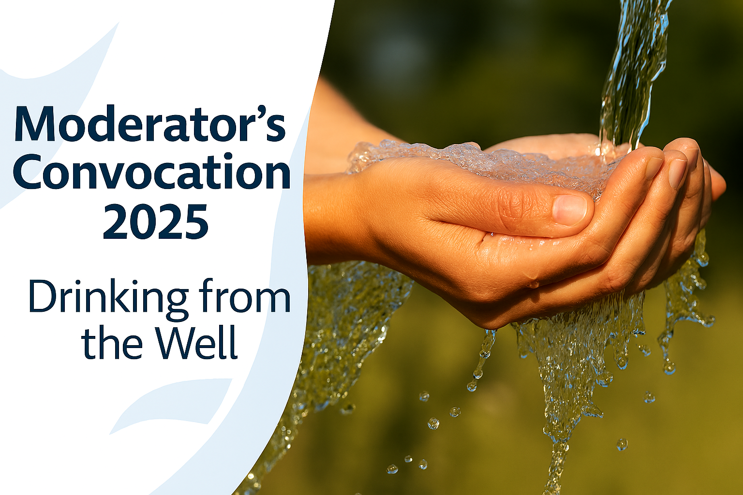
Dear colleague in ministry,
I am excited to invite you personally to participate in Moderators Convocation that is being held in Mary Burnett Presbytery on 10th October at Nambour Uniting Church. As you may be aware I have already hosted 3 other such gatherings in regional locations throughout the Synod over the last 12 months and ministry leaders have really valued the opportunity to take time out to personally reflect and seek God amongst the demands of ministry.
I wanted to just take a moment to connect with you briefly ahead of time to give you a bit of a sense of the heart, vision and process of the day we are planning. As your Moderator, I am passionate about engaging with and leaning into the renewing work that God has for each one of us and for us as the church. It is my hope that these convocation days allow us all to courageously reimagine our story and our part in Gods greater story.
This convocation is about providing a facilitated opportunity and space for each one of us to access our curiosity, courage and imagination, to refine and realign with our core values; and to explore, amplify and reimagine the stories of ourselves that God wants us to enjoy and flourish in ministry.
Whilst Presbytery is always a great opportunity to catch up with friends and colleagues, I invite you to come prepared to engage fully with the process we have put together. I encourage you to lean into the space for deep and personal reflection and allow God to do transforming work in our hearts.
Perhaps allow your curiosity for what God may want to say to you, ignite a passion to go beyond your normal comfort zone, to see what opportunities for growth, beauty and a new story God may have for each of us as individuals and together as the church.
I look forward to seeing you there and doing this together, as the Spirit would lead.
Grace & peace,
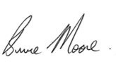
Rev Bruce Moore
Moderator

The Uniting Church in Australia Queensland Synod recognises the importance of providing a safe and flourishing ministry environment and that personal mental health and wellbeing is vital to being able to effectively serve in ministry.
The Moderators Regional Convocations - Drinking from the Well aims to provide opportunities in regional locations across the Qld Synod for Ministry Agents and other leaders serving on councils and committees across the life of the Church. This will be a retreat style experience to re-centre yourself with God, gather in community and share some tools and resources that will assist you in better looking after your wellbeing in the ministry.
An opportunity for those in the UCA to gather in community and be encouraged in their call.
On behalf of Rev Bruce Moore, Moderator, Queensland Synod, I would like to invite you to attend Moderators Convocation 2025.
We will be holding our final regional convocation forum at Nambour Uniting Church:
Location: Nambour Uniting Church, 37 Coronation Avenue, Nambour Queensland 4560
Date /Times: Friday 10th October 2025
Time: 9:00am - 4:00pm (approx.)
Cost: This will be a free event with morning tea, lunch and afternoon tea provided
Register here: https://www.trybooking.com/DCQRH
Please RSVP via the registration link by Friday 3rd October 2025
If you have any questions regarding registration, please reach out to Vanessa Van Der Rhede by email: events@ucaqld.com.au

