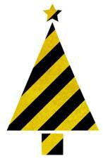

**“Safety is that state of being when risks and the hazards derived from it are determined acceptable or in control”**



Yes, our festive season is fast approaching with many activities occurring, increasing numbers of people and traffic at our locations, increase in temperatures, potential storm events, increased use of

electrical goods and potential fire events to name a few possibilities. Below we share some reminders to assist you to identify and manage your risks in keeping

with the Church vision, values and our Work Health and Safety compliance requirements. Note# There may be many other issues to consider.

MCj04078800000[1]

**Electrical Safety**

Electricity can shock, burn, damage nerves and internal organs, kill people and also result in fire, explosion and serious property damage

**General**

* Extension cords – avoid or minimize their use where possible, ensure they carry the Regulatory Compliance Mark (RCM) http://www.comtest.com.au/sites/default/files/styles/300_wide/public/RCM%20final.png?itok=5EzvouQr, and

        protect from damage and keep away from water and walkways

* Use only power boards that are surge protected, carry the RCM and preferably individually switched
* Immediately isolate, remove from service and lock out/tag out unsafe/faulty electrical equipment
* Electrical equipment which is loaned/hired out (even if monies are not exchanged) must
  + be inspected, tested and tagged by a competent person every 6 months: and
  + record a visual inspection of the equipment prior to loan/hire
* If there is not an RCD installed then electrical equipment is to hold current test and tag
* Install outlet covers in areas accessed by children
* Prohibit the use of double adaptors and daisy chaining power boards
* Immediately report any minor shocks or “tingles” from electrical equipment or electrical infrastructure (wiring, switches or plugs)

        to a Church Representative and also advise WHS Qld Synod Office. Immediately remove that equipment from service and tag out of service

**Festive lighting**

* Read the manufacturer’s instructions carefully before use – exercise extreme caution when purchasing electrical items online or from a Discount Store
* Look for the Regulatory Compliance Mark logo, which indicates compliance with Australian Standards
* Inspect festive lighting before use for any damage, wear and tear
* Turn off festive lighting when no one is in attendance

**Festive lighting - Extension cords**

* Do not use cords that have damaged insulation or exposed wires
* Do not expose joins in extension cords to the weather
* Cover extension cords that are lying across walkways and do not lay across driveways
* Unwind extension cords fully to avoid overheating

**Festive lighting** -**Outdoors**

* Ensure all lights, extension leads and power boards are specifically designed and approved for outdoor use
* Check all outdoor connections are weatherproof and are suitable for their intended use
* Don’t pass electrical leads through doors and windows
* Secure lights to minimise the risk of breakage in wind or storms
* Use extra-low voltage equipment when attaching lights to fences, metalwork, roofs and downpipes
* Avoid placing temporary festive lighting above or around water features
* 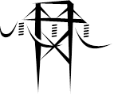Keep yourself and your lights well clear of overhead powerlines - at least 3m away

**Overhead Power Lines Remember:** People and equipment should not

approach overhead power lines any closer than the following distances

|  |  |  |
| --- | --- | --- |
| Power lines with voltages up to 132000 volts | e.g. low voltage and high voltage distribution and sub transmission lines, usually on poles | 3m |
| Between 132000-330000 volts | e.g. sub transmission and transmission lines on either poles or towers | 6m |
| More than 3300000 Volts | e.g. transmission lines usually on towers | 8m |

* Look around and identify overhead lines – especially if planning to use a ladder
* On hot days power lines can sag, On windy days power lines can sway
* Dim light at dusk or dawn or on overcast days can make power lines more difficult to see
* Your angle of vision can distort the apparent height of power lines
* You can still be injured without directly contacting an overhead power line; remember that electricity can arc across open spaces

**Using Ladders /Fall Prevention**

* If you work at height >2m then you need a means to prevent the fall
* Avoid standing on furniture for indoor decorating - use a step ladder instead but not the top step
* When using a step ladder do not climb above the third top step, and ensure it is on the fully locked position before climbing
* Ladders must meet AS/NZS1892- Portable Ladders and be “Industrial” rated

Portable Ladders *-* Extension or single ladders should generally only be used as a means of access to or egress from a work area.

They should only be used as a working platform for light work of short duration that can be carried out safely on the ladder.

Where a portable ladder is used, the following requirements apply:

* Only **“permitted work”** may be done i.e.
  + where the weight, size or shape of any equipment or material the person using the ladder is carrying is not likely

to restrict the person’s movement while descending or climber ladder

* + cause the person to lose balance on the ladder while doing the work
  + the person’s trunk is approximately centred over the centre of the space between the sides of the ladder
  + any equipment being used by the person can be operated using 1 hand unless a control measure designed to support the

person’s body is being worn or used. (i.e. must be able to maintain 3 points of contact)

* Angle ladder 4:1(base of the ladder is 1 meter out from the supporting wall, for every 4 meters of supported length)
* Use an insulated ladder where a potential electrical hazard exists

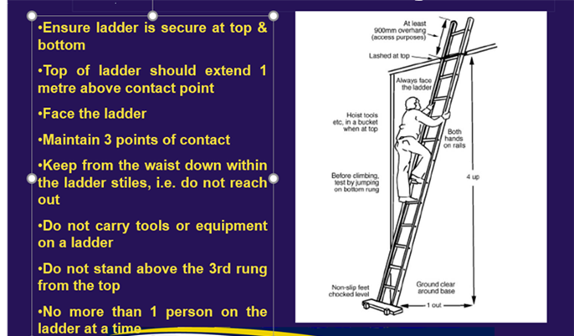

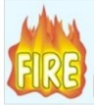

**Fire Prevention**

Christmas trees and the lights and other decorations with which they are adorned are all fire hazards

Fires involving Christmas decorations may occur as a result of electrical faults, because decorations are placed too close to heat sources

* Choose an artificial Christmas tree which is labelled “Fire Resistant” or a real fresh “green “pine tree
* Use non-combustible or flame-resistant decorations if able e.g. tinsel made from plastic
* Make sure your tree is stable and does not cause any obstruction to fire exits etc
* [Candle safety](http://www.cofcinsurance.org.au/news/avoiding-candle-fires-in-your-church/) – provide non-flammable holders for candles, or opt for a flame-free alternative such as LEDs, glowsticks or battery-operated candle lights.
* Ensure Fire Fighting appliances are within their 6 monthly checks and remain unobstructed at all times
* Be aware of your locations Fire Evacuation Plan and assembly areas



**Heat Stress/UV Radiation**

* Drink plenty of cool fluids to avoid [dehydration](https://www.myvmc.com/medical-dictionary/dehydration/), take regular breaks
* Use sun protection ( shade, broad spectrum 50+ sunscreen, a hat and protective clothing
* Avoid the outdoors to do works between 10-2pm where possible
* Ensure adequate cold water, fans are available for church services and functions
* Have first aid trained person on location where possible and up to date First Aid Kit
* Check your yard, balcony - secure or store items that could blow around in strong winds

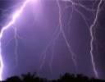

**Severe Weather Events e.g. Storms**

Storms may bring heavy rain, damaging winds, lightning, hail, floods and can cause damage to property, the environment or people

* Check the Bureau website or app and listen to your local radio station for storm warnings and updates
* Ensure Emergency Plan is up to date and readily accessible
* Cancel outdoor activities as required
* Maintain gutters, downpipes and drains, check trees branches are trimmed as identified
* Ensure back up lighting options are in good working order, adequate battery supplies
* Always keep away from fallen powerlines
* Ensure mobile phone batteries are fully charged

**Safety of Children**

Remain vigilant and comply with the Church established SafeMinistry for Children standards and practices

**Additional considerations include**

* May need to roster additional volunteers to assist with managing people attending or parking
* Attention to security measures – buildings and cash handling
* **Avoid tree and other decorations that are sharp or breakable,** hold small removable parts (inhalation/swallowing hazard) or resemble “candy”



**Please Keep Safe and Healthy – Always**

If you require WHS or Fire Safety advice or assistance in regard to your upcoming Christmas activities/eventsplease contact***:***

Christine Przibilla , Qld Synod WHS Manager 07 3377 9946 or Peter Rose Qld Synod Inspection & Support Representative 07 3377 9729