INCIDENT(S)
It has been reported that on a number of occasions the level 2 kitchen sandwich maker has been left on after use, thus resulting in the paper contained within the appliance to start smouldering.

The current appliance does not have an automatic cut-off switch, thus relies on the person using the item to use the appliance in the correct manner.
The staff member whom raised this issue is to be commended.

Actions required/TAKEN by Qld Synod Office
- Person’s using the sandwich maker are required to stay present whilst their item is being cooked, turn off the power to the sandwich maker at the power point when item is cooked and dispose of the paper in the appliance.
- Our Office Services are investigating the option to purchase a sandwich maker with an automatic cut off. An interim warning sign in the area has been placed.
- If required, we will investigate the option to have a timed power point operation installed.
- All persons are requested to proactively keep our workplace and ourselves safe

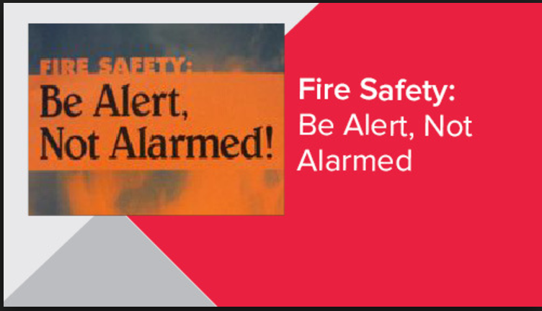

For clarification or assistance in relation to this alert please do not hesitate to contact the writer.
Safety Alert Prepared By: Christine Przibilla, WHS Manager Qld Synod

