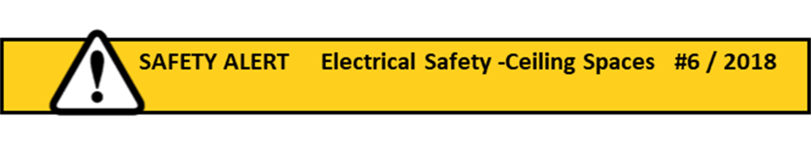

**Do any persons at your location (work or home) enter or may enter a ceiling space?**

The Electrical Safety Office has recently issued a Safety Alert to businesses in relation to ceiling space wiring and

non-compliant wiring installation practices in accordance to the new edition AS/NZS 3000 (Wiring Rules).

Electrical Safety Inspectors will be conducting audits of existing and new installations. [WHSQ Safety Alert - Click Here](https://www.worksafe.qld.gov.au/forms-and-resources/newsletter/esafe-newsletters/esafe-editions/esafe-electrical/2018-bulletins/ceiling-space-wiring-is-your-work-compliant)

However, it is also a good reminder for us all to review our electrical safety practices: i.e.

* Ensure only currently licenced electrician perform electrical work in accordance with the current Wiring Rules;
* Ensure insulation materials in the ceiling do not cover electrical fittings e.g. downlights;
* Switch off all Main Switches at the Switchboard before any person enters into the ceiling space;
* Ceiling spaces are considered to be high risk work locations and electrical shock potential in ceiling spaces is real (e.g. damaged or exposed live wiring)
* Ensure someone is on standby when a person is working  in a ceiling space;
* Other hazards in these spaces may include vermin, excessive heat, asbestos-containing materials.

**Remember to:**

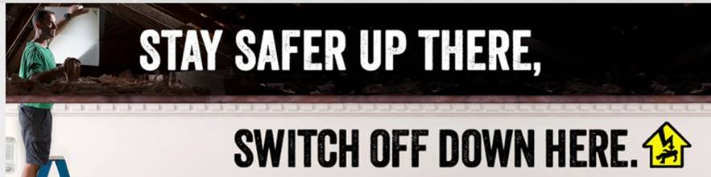

If you would like any further information/assistance or a copy of a Safe Work Method Statement for Ceiling Space Work (Generic)

Please contact Christine Przibilla, WHS Manager Qld Synod Office 33779946 or 0439136 171