SAFE OPERATING GUIDELINES

SAFEMINISTRY WHS Ride On Mower
DO NOT use this machine unless you have received instruction
in its safe use, operation and maintenance

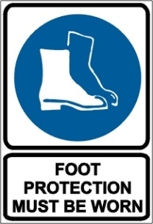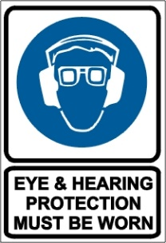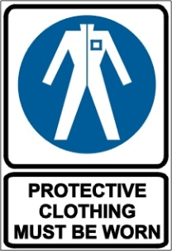

POTENTIAL HAZARDS include
Rapidly rotating cutting blades, Noise, Eye injuries, Ejected material and flying debris, Rollover potential

PRE-OPERATIONAL SAFETY CHECKS
- Ensure all safety devices, guards, switches, and shields are fitted, secure and functional
- Ensure that seat belt, if fitted, is in sound condition
- Ensure cutting blades are secure and in good condition
- Ensure that any pneumatic and hydraulic mechanisms are in sound condition
- Ensure that all electrical switches (including dead-man switch if fitted) are functioning
- Faulty equipment must not be used; Report faulty machinery immediately and TAG OUT OF SERVICE

OPERATIONAL SAFETY CHECKS
- Never carry passengers
- Be sure the transmission is out of gear and the mower blade clutch disengaged before starting
- Keep clear of moving machine parts
- Drive at speed slow enough to keep control over unexpected hazards e.g. stumps, ditches
- Travel up/down slopes rather than across -caution when ascending/descending steep slopes. Use 150 as the maximum to attempt to mow
- Refuelling - prevent spilling fuel onto hot engine or exhaust
- Before making adjustments bring the machine to a complete standstill and isolate
- Be aware of the potential for ejected material and ensure that no person or animal is endangered when operating the equipment

STOPPING THE RIDE ON MOWER
- Park on even ground
- Stop the ride on mower and shift the gear selector to park position
- Raise and secure the cutting blades
- Lock the parking brake
- Stop the engine and remove the keys

HOUSEKEEPING
- Clean away any foreign material and debris from in and around engine and catcher parts – Isolate Power First
- Keep work area and storage shed in a clean and tidy condition

