SWMS DETAILS
Congregation/Location: |  | Organisation: Uniting Church Qld Synod ABN: | Date / /
Persons involved in creating the SWMS  (2 or more persons) | Print Names and Positions |  | Insert Identifier E.g. Purchase order
Describe the job/activity you are performing
Describe the specific location (building, Area, structure (floor, room, roof);
Access Point Location where this job will take place, if relevant
List Formal Training, Licences required for workers undertaking this task | ☐Blue Card (Working with Children) ☐Electrical Work or Electrical Contractor Licence ☐ Enter and Work in Confined Spaces (RIIWHS202D) ☐ List Other ☐Work Safely in the Construction Industry (CPCCOHS1001A) - White Card ☐Working Safely at Heights (RIIWHS204D) ☐
Is there a procedure applicable to this job | ☐ e.g. Working at Heights Procedure ☐
Identify the Personal Protective Equipment or Clothing and Resources Required
Foot Protection | Hand Protection | Hearing Protection | Eye Protection | Face Protection | Head Protection | High Visibility | Protective Clothing | Sun Protection | Fire Fighting Equipment | Spill Kit | Safety Signage | Safety Data Sheets | First Aid Kit
 |  |  |  |  |  |  |  | Broad brimmed hat, UV rated clothing, SPF 50+ sunscreen, tinted safety glasses with adequate UV protection) | 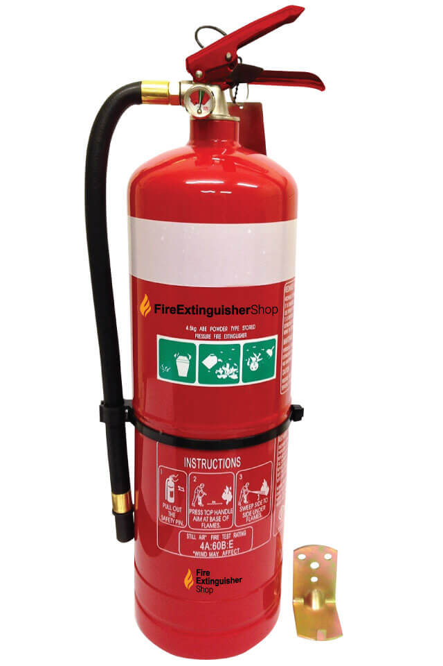 | 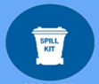 | 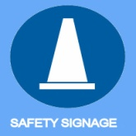 | 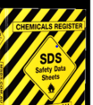

List the main tools and safety equipment required to complete the job:
☐Lock Out/Tag Out Equipment ☐Communication - Radio or mobile phone ☐Lanyard to secure tools ☐Ladder – Non-conductive – Extension ☐Ladder – Non-conductive -Step-Platform ☐Barricading /bollards
☐Signage ☐EWP/Boom Lift ☐List Other:
Other:
☐Work Permit ☐Rescue Plan ☐Asbestos Register ☐List Other:

Refer to Safety Hazard and Environmental Impacts List and Risk Matrix at end of this document for guidance
Job Steps  List the required steps in sequence | Hazards /Risks – What are the potential safety and environments hazards that can cause harm/damage?  What can cause harm? What can Happen? | Control Measures / Actions  What are the controls to eliminate or minimize the risk? | Has the hazard/risk been effectively controlled? Y/N  State the Residual Risk Rating with Controls in place  (refer Risk Matrix) | Person(s) responsible for control
e.g. Placing ladder into position | Contact with overhead power lines →electrical shock | Two persons to undertake task, one as spotter: keep clear of overhead power lines and maintain electrical exclusion zone: if necessary have power cut if safe electrical exclusion zone cannot be maintained | Y - Low | J. Smith  B. Smith

SIGN OFF (Employees, Volunteers and Contractors)
I have read the above SWMS and understand its contents. I confirm that I have the skills and training, including any relevant certification to conduct the tasks as described.
I agree to comply with safety requirements within the SWMS
Full Name (Print) | Position | Signature | Full Name (Print) | Position | Signature
SWMS AUTHORISATION (i.e. Property Officer, Minister)
I acknowledge that I have reviewed the SWMS in consultation with the workers undertaking this work activity.
Authoriser Full Name: Position: Signature: Date: / /

SAFETY HAZARDS & ENVIRONMENTAL IMPACTS TO CONSIDER include:
Physical Work Environment | Mechanical/Equipment | Work Tasks | Environmental Impact
☐ Fall from Height | ☐ Vehicles / Mobile / Fixed Plant | ☐ Repetitive movements | ☐ Protected species – e.g. snakes
☐ Falling Objects | ☐ Powered Equipment / Tools | ☐ Awkward postures | ☐ Air (dust, Gas)
☐ Trips & Slips | ☐ Non- Powered Equipment / Tools | ☐ Lifting / Handling | ☐ Water Contamination
☐ Restricted Access ☐ Confined Space |  | ☐ Restricted or Confined Space Entry | ☐ Waste –generation and disposal
☐ Inadequate Work Space | Work Environment Conditions | ☐ Working at Height | ☐ Air (dust, Gas)
☐ Ventilation / Air Quality | ☐ Noxious weeds | ☐ Working Alone / Late | ☐ Noise pollution
☐ Noise / Vibration | ☐ Weather / temperature extremes | ☐ Hot work e.g. welding | ☐ Flora/Fauna
☐ Heat / Cold | ☐ Vegetation | ☐ Psychosocial aspects e.g. violence, fatigue, bullying | ☐ Soil Contamination
☐ Lighting | ☐ Water Hazards
☐ Hit by objects | ☐ Venomous/dangerous species | Energy Sources
☐ Hitting objects | Hazardous Chemicals/ Dangerous Goods | ☐ Fire / explosion
☐ Entrapment / Collapse | ☐ Chemicals | ☐ Electrical – incl. overhead and underground cable
☐ Fragile / Unstable Surface | ☐ Gases | ☐ Pressure
☐ Uneven / Sloping or Slippery Surface | ☐ Flammable / Combustible | ☐ Compressed Air
☐ Vents / Pipes / Extraction Units | ☐ Dusts / Fumes | ☐ Radiation –Ultra-Violet, Electromagnetic, Welding, Lasers, Radiofrequency

☐ Ceiling Space
☐ Skylights and Penetrations | ☐ Radioactive Agent | Biological
☐ Holes, Openings or Excavations | ☐ Asbestos | ☐ Animal or human tissue/fluids
☐ Moving vehicles /Traffic |  | ☐ Plant materials
☐ Security Systems and arrangements |  | ☐ Food Handling- e.g. harmful bacteria

Risk Rating Matrix

The Risk Matrix provides a guide to assist in assessing the risk potential and subsequent Control Measures to be put in place to adequately manage the risk.
It is suggested that the use of this risk matrix is undertaken by at least 2 persons and the resultant risk ratings are based on the current control measures you have put in place.
1st What is the most probable consequence of the unwanted event, incident or circumstance occurring?
2nd What is the realistic likelihood of the unwanted event, incident or circumstance occurring?
3rd Use the Matrix below to see where the criteria from the Consequence and the Likelihood tables intersect

Consequence | 1.Negligible | 2.Minor | 3.Moderate | 4.Major | 5.Severe
Work, Health, Safety & Environment (WHS&E) | Limited harm  First aid treatment  Return to pre-existing condition within 24 hours  Negligible environmental impact | Injury or illness  No lost time  Minor medical treatment  Return to pre-existing condition within 1 week  Minor localised environmental impact | Serious compensable injury, Extended time off >7 days  Return to pre-existing condition within 1 month  Material environmental impact | Injuries requiring hospitalisation  Permanent impairment due to injury  Return to pre-existing condition within 3 months  Serious environmental impact | Fatality or numerous serious injuries  Unable to return to pre-existing condition  Long-term environmental harm

Consequence
Likelihood | Probability | Description | Frequency | 1.Negligible | 2.Minor | 3.Moderate | 4.Major | 5.Severe
Frequent | >90% | Is expected to occur – almost inevitable | >10 times per year | Medium | Medium | High | Extreme | Extreme
Likely | 70 – 90% | Will probably occur in most circumstance – not surprised if it happens | More than once in 12 months | Medium | Medium | High | High | Extreme
Possible | 30 – 70% | Might occur at some time | Once in more than 3 years | Low | Medium | Medium | High | High
Unlikely | 5 – 30% | Could occur at some time – surprised if it happens | Once in 5 years | Low | Low | Low | Medium | High
Rare | <5% | Highly unexpected – considered exceptional circumstance | Once in >5 years | Low | Low | Low | Medium | Medium

